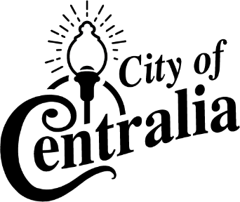

PUBLIC NOTICE
FOR
SALE OF CITY PROPERTY

The City of Centralia, Missouri hereby announces the sale of public property located at 801 E Switzler, Centralia, MO 65240. The property will be sold via a sealed bid process with a minimum bid of $435,000.
Property Description:

Address: 801 E Switzler, Centralia, MO 65240
Parcel Number: 04-220-00-01-017.00 01
Lot Size: 102.33 × 282.00
Property Type: Commercial
Zoning: R-2, Two Family Dwelling
Brief Description: Approximately 7560 Sq Ft building containing: an office, restrooms, full kitchen, versatile event space, and is ADA compliant. Some contents being sold with building.
Minimum Bid: $435,000

The sealed bids must be submitted to the City Clerk's Office located at 114 S. Rollins St., Centralia MO 65240, no later than Friday May 17, 2024, at 4:00 P.M. Bids will be opened and considered during a public meeting of the City Council on Monday May 20, 2024, at 6:30 p.m.

All interested parties are invited to participate in this sealed bid process. The City reserves the right to accept or reject any or all bids received, in whole or in part, and to waive any technicalities or irregularities in the bids.

For additional information or to set up a viewing of the property, please contact: Matthew Rusch, Director of Public Works and Utilities, MRusch@centraliamo.org or 573-682-2139.

114 S. Rollins St. Centralia MO 65240

DATED this 24th day of April, 2024.
By Order of the Board of Aldermen
City of Centralia, Missouri
Marilyn Dick, City Clerk

